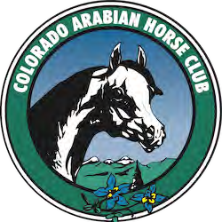
September 2026 Newsletter
In This Issue
CAHC Board of Directors
Newly Elected Directors
Youth Club News, High Point Awards Youth
The Fall Show
Membership Application

Your Club Officers and Board of Directors

President
Vice-President&DelegateChair Secretary
Treasurer
Stephen Bishop Kelly Meyer Eri Hook
Cheryl McMahon
stephenbishop@comcast.net mrsbrentmeyer@gmail.com cahcsecretary@gmail CherylMc22@gmail.com

Immediate Past President Chuck Mangan

Directors

Jim Hitt Michelle Taylor Grace Rushing
Trisha Swift-Northern Div
Lauren Payne-SouthernDiv
Carrie Jacobucci
Mark Helmick Bliss Hancock

Junior Club Advisor Horse Judging Leader Horse Judging Leader
Angela Mannick
Kendra McConnell Rachel LeClure
hockeyandhorsemom@gmail.com

Communication and Website Kelly Meyer
CAHC At A Glance
Membership Cheryl McMahon
Newsletter Editor Stephen Bishop

The CAHC Board is made up by the following:
Executive Committee:
Stephen Bishop - President Kelly Meyer - Vice President Cheryl McMahon - Treasurer Eri Hook - Secretary
Chuck Mangan - Immediate Past President
Board Members expiring in 2026 (Elected in 2024 to serve a 2 year term) Bliss Hancock
Mark Helmick Carrie Jacobucci
Board Members expiring in 2027 (Elected in 2025 to serve a 2 year term) Jim Hitt
Grace Rushing Michelle Taylor

Southern Division Representative:

MaryJo Hoepner

Northern Division Representative:
Trisha Swift

Youth Advisor:
Angela Mannick

The following are the committee chairs as I know them. They do not hold a vote on the Board meetings unless they are listed above. I just took Eri's list and made a couple of comments.
ACTIVITIES – Kelly Meyer (this is always the club's VP) AHA CLUB EXCELLENCE AWARD – Grace Rushing
AWARDS – Angela Mannick (for Youth awards) and Bliss Hancock (for Adult awards) BY-LAWS –
CABA – Jim Gromelski
COLORADO HORSE COUNCIL – Steve Bishop
COMMUNICATIONS – Mark Helmick COMMUNITY RELATIONS –
CONVENTION: Delegates – Grace Rushing, Cheryl McMahon, Jim Hitt, Trisha Swift
DRESSAGE – Mary Jo Hoepner FINANCE – Executive Committee

FINANCIAL REVIEW – This is Gwen Mahoney. HUNTER JUMPER – Chuck Mangan INSURANCE – Lauren Payne
MEMBERSHIP – Cheryl McMahon NEWSLETTER – Stephen Bishop NOMINATING COMMITTEE – Michelle Taylor VOLUNTEER AWARDS COMMITTEE – WORKING HORSE – Jim Hitt

Congratulations to our newly elected officers!



The Colorado Arabian Horse Club held its election of three Main Club Board of Director seats at the CAHC Fall Show this past weekend.

Newly elected Directors, Delaney Haight and Shauna McIntosh re-elected Director, Mark Helmick.
join
Continuing officers include President, Dr. Stephen Bishop; Vice-President, Kelly Meyer; Secretary, Eri Hook; Treasurer, Cheryl McMahon; Immediate Past President, Chuck Mangan.

Continuing Directors are Grace Rushing, Jim Hitt and Michelle Taylor.

Congratulations and thank you for your commitment to the Colorado Arabian Horse Club!

1/1

Upcoming Events & Shows

No Frills Classic Spring Show
Spring of 2027

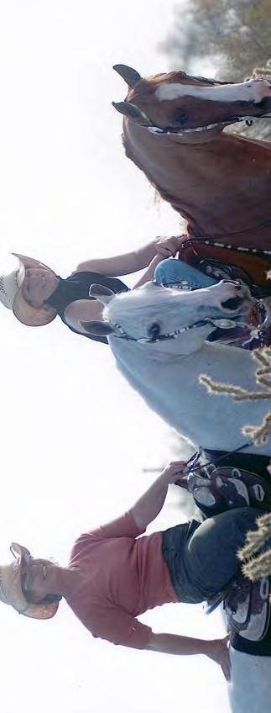
Photo: Kathy Troxler & Sharon Lujan
*More Information & Entry Forms Can Be Found On coloradoarabianhorseclub.org

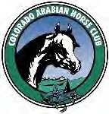
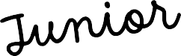
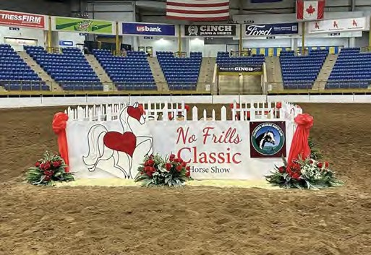
Get Involved!!

Colorado Arabian Horse Club News
Don’t forget to send in your entry forms and tell all of your 4-H friends about this year’s 4-H Extravaganza and 4-H youth clinics.
Join us Friday evening, April 24th, during the Spring No Frills Classic Show to celebrate all of the CAHC 2025
Youth High Point Award winners!

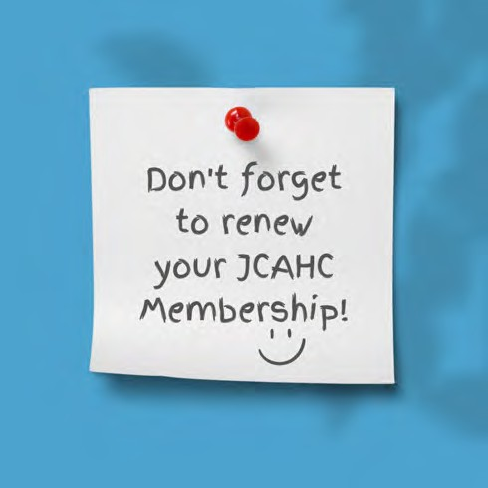
Scholarship Opportunities

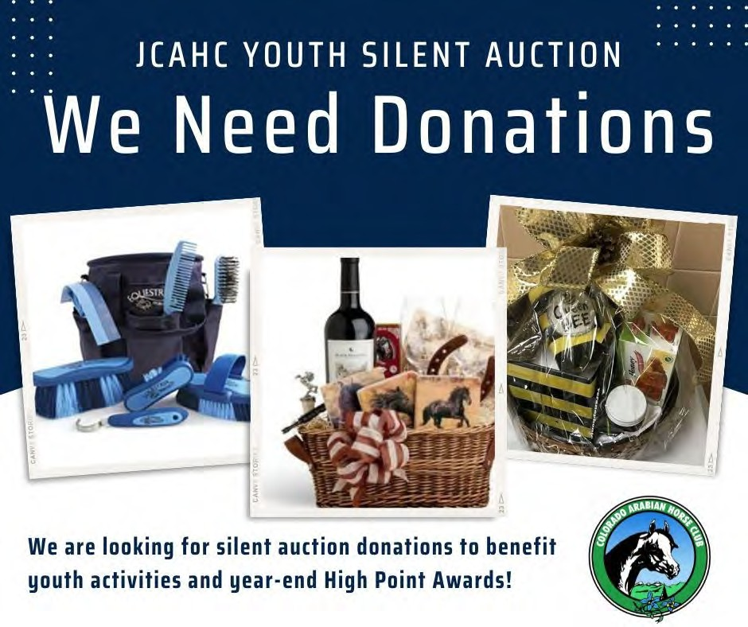
National Arabian Horse Judging Contest
Contestants in the National Arabian Horse Judging Contest at U.S. Nationals in October have the opportunity to win $7,000
in total individual and team scholarship awards across the three divisions: 4-H/FFA, Junior AHA, and Senior AHA/Collegiate.

Burr Betts Memorial College Scholarship
Two scholarships of $1,000 each to be awarded to two incoming college Freshmen or current undergraduate or graduate
students, or to incoming or current students at a trade school or other post high school educational program of at least one year in length. Applicant must be a member of an AHA Region 8 affiliated club. Applicant must have completed at least 8 hours of volunteer service to Region 8, the affiliated club, or other equine organization in the year prior to applica-tion. Deadline is May 1.

Rise Up and Ride On
Interested in attending youth nationals for the first time? Apply for our grant to help cover your entry fees! Offered through Region 9’s Youth page, entries are due by May 8th.
You can reach Angela Mannick, JCAHC Youth Director, at 303-324-3507
or HockeyandHorseMom@gmail.com

Youth High Point Awards 2025

Western Pleasure 10 & Under - Crake Tucker Western Pleasure 14-18 - Grace Landwehr Equitation 14-18 - Grace Landwehr Working Western Overall - Brielle Stack

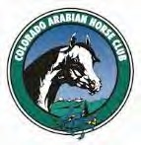
Membership Application
For faster and more efficient Affiliate Membership processing, you can join Online at www.arabianhorses.org Please be sure to mark CAHC (Club #8033) as your Affiliate Club.
First Name: Last Name: AHA #:
Address:
City: State: Zip:
Tel: Email:

(Very important to receive club information, news and updates)
CAHC/AHA AFFILIATE MEMBERSHIP – Affiliate Individual Membership (AHA Member with AHA, Region 8 and CAHC Benefits to include Voting Privilege in each)

Base Affiliate Membership without Competition Card

YOUTH BIRTHDATE:
Base AHA/CAHC Affiliate Membership with Competition Card & Insurance

CAHC ASSOCIATE MEMBERSHIP –
Adult 1 Year @ $75.00 $ Adult 3 Year @ $205.00 $ Youth 1 Year @ $25.00 $

Adult 1 Year @ $110.00 $ Adult 3 Year @ $310.00 $ Youth 1 Year @ $50.00 $

Associate Individual Membership (Not an AHA member, or does not have AHA affiliation
through CAHC: all benefits of membership except those specific to AHA and Region 8; no voting privilege in any organization). Associate memberships expire 12/31 of each year.
Adult 1 Year @ $25.00 $ Adult 3 Year @ $70.00 $ Youth 1 Year @ $5.00 $
TOTAL: $
DIVISION INTEREST (Check all that apply): MAIN CLUB NORTHERN SOUTHERN YOUTH

Areas of Interest:
Club Officer Director Activities
Awards Committee Youth

Horse Shows Other (List any area you would like involvement with:
Show Manager Show Secretary Barn Manager Gates Manager Hospitality

MAKE CHECKS PAYABLE TO CAHC AND MAIL TO: Cheryl
McMahon, 21710 E. Heritage Parkway, Aurora, CO 80016 (303)
881-7203 Revised 05/27/21

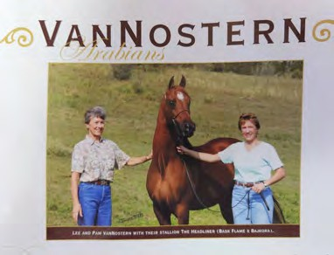

Dear CAHC Members,
With heavy hearts, we share the passing of longtime Colorado Arabian Horse Club member Lee Van Nostern on September 29, 2026.
Lee shared a lifelong passion for Arabian horses with her daughter, Pam, building a business together devoted to training, showing, and breeding. Her love of horses and the friendships she made will remain a cherished part of our Arabian horse community.
We extend our heartfelt condolences to Pam, her family, and all who knew and loved Lee.

With deepest sympathy, Colorado Arabian Horse Club


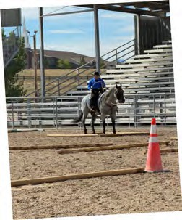
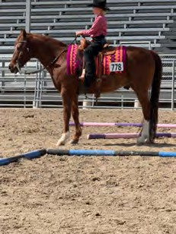
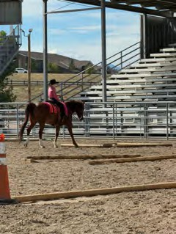
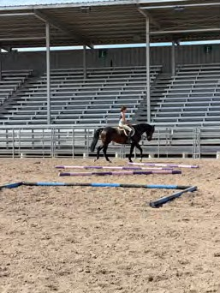
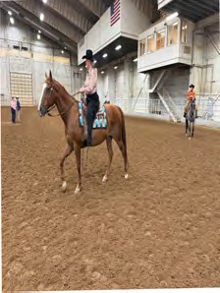
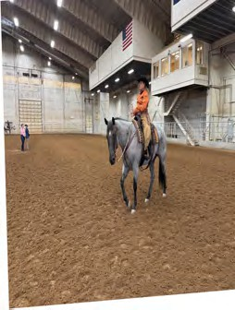
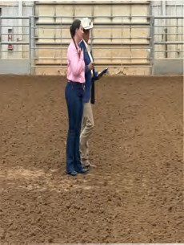
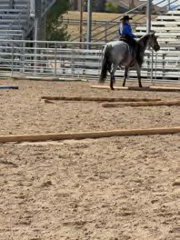
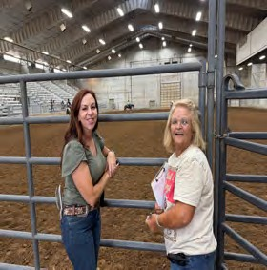

Photos from the Fall Show

